Maria Jose Viveros Riquelme
Professor Anna Devarakonda
ITAI 2372
April 8, 2026

Testing Plan. Conceptual Design and Testing Framework for Early Rheumatoid Arthritis Risk Screening

The testing plan for RA-HandRisk is designed to evaluate whether the system can function as a reliable screening support tool rather than as a diagnostic instrument. This distinction matters because rheumatoid arthritis diagnosis usually requires broader clinical assessment, including laboratory testing and imaging, while the proposed system only estimates early risk from survey data and hand images. In addition, rheumatoid arthritis commonly affects the small joints of the hands and is associated with factors such as age, family history, and smoking, which supports the decision to test a model that combines visual and structured inputs rather than relying on images alone.
The first stage of testing would focus on dataset design and ground truth definition. The system would require a labeled dataset containing hand photographs, survey responses, and a clinical reference label for each participant. The reference label should not come from the model itself, but from documented medical evaluation, ideally based on clinician-confirmed rheumatoid arthritis status or clinically verified early inflammatory arthritis categories. Because the goal is screening, the dataset should include not only confirmed rheumatoid arthritis cases but also non-RA controls and patients with other hand-related conditions, such as non-inflammatory musculoskeletal complaints, so the model is tested against realistic ambiguity rather than an artificial yes-or-no scenario. This is especially important because RA symptoms can overlap with other conditions and because early disease may be subtle.
The second stage would evaluate input quality and data completeness. Before testing the prediction model itself, the system should verify that survey responses are complete and that images meet minimum quality requirements. For example, the image quality module should check whether both hands are visible, whether lighting is sufficient, whether the background allows contour detection, and whether the fist image shows actual closure. Likewise, the survey module should verify that key variables such as age, sex, smoking history, morning stiffness duration, bilateral pain, and family history are not missing. If critical inputs are absent, the system should not generate a risk score and should instead request resubmission. This step follows good machine learning practice principles emphasizing appropriate data quality and clear information for users.
The third stage would test the survey module separately. In this phase, the structured variables would be examined to confirm that the questionnaire correctly captures clinically relevant risk information. For example, age should be grouped into meaningful categories, smoking should be coded as never, former, or current, and morning stiffness should be converted into ordered duration ranges. A practical way to test this module is through rule-based validation cases. For instance, a hypothetical profile with prolonged morning stiffness, bilateral hand pain, family history, and smoking exposure should generate a higher structured-risk profile than a profile without these features. This step does not prove medical accuracy by itself, but it verifies that the survey logic reflects known RA risk patterns reported by official clinical sources.
The fourth stage would test the image analysis module independently. This module should be evaluated for its ability to detect visual signals such as swelling around small joints, hand symmetry, contour changes, and incomplete fist closure. A subset of images should be manually reviewed by clinical experts or trained annotators to create reference annotations for swelling regions, visible deformity, or functional limitations. The model’s extracted features can then be compared against these annotations using agreement metrics. In practical terms, this means checking whether the system consistently identifies the same suspicious regions or hand-shape limitations that humans identify. Since rheumatoid arthritis often affects the small joints of the hands and may present symmetrically, testing should explicitly include symmetry detection and small-joint region performance.
The fifth stage would focus on integrated model validation, where survey-derived variables and image-derived features are combined into one risk estimate. At this point, the model should be evaluated on a training, validation, and holdout test split, or alternatively through cross-validation if the dataset is limited. The main purpose is to estimate how well the integrated system distinguishes higher-risk from lower-risk participants on unseen cases. Because this is a screening system, the most important evaluation metrics should include sensitivity, specificity, precision, recall, accuracy, and area under the ROC curve (AUC). Sensitivity is especially important because a screening tool should minimize missed high-risk cases, while specificity remains necessary to reduce excessive false alarms. Reporting these metrics is also consistent with modern prediction-model reporting guidance such as TRIPOD+AI.
A sixth stage should address fairness, subgroup performance, and generalizability. Since rheumatoid arthritis is more common in women and older adults, a model trained on imbalanced data could perform unevenly across demographic groups. Therefore, performance should be reported separately by sex, age range, and, if available, race or ethnicity and socioeconomic setting. In addition, if images come from different phones, clinics, or lighting conditions, the model should be tested across those acquisition differences to confirm that performance does not collapse outside a narrow technical setting. This is important because good machine learning practice emphasizes representative data and human-AI performance in real contexts, not just ideal lab conditions.
The seventh stage should evaluate human factors and usability. Even if the model performs well statistically, the output must still be understandable to users and clinicians. Therefore, usability testing should examine whether participants can complete the survey without confusion, whether they can capture acceptable hand images, and whether they understand the final result categories of low, moderate, or high risk. In addition, clinicians or evaluators should review whether the factor summary is meaningful and whether the recommendation language is clear without sounding diagnostic. This aligns with guidance that machine-learning-enabled medical tools should provide transparent and essential information to users.
The eighth stage should include safety testing and error analysis. Here, the main focus is not only average performance but also identifying when the model fails. False negatives are particularly important because they may delay care for high-risk individuals, while false positives may create unnecessary anxiety or referrals. Error analysis should therefore examine cases with low image quality, borderline symptoms, or conflicting signals between survey and image modules. For example, a case with strong clinical symptoms but minimal visible swelling should be reviewed to understand whether the model underweights symptom data. Likewise, cases with visible hand abnormalities but weak survey risk should be analyzed to determine whether the image model is confusing RA with another hand condition. This kind of review is essential for safe development of AI systems in healthcare.
A ninth stage should define success criteria before testing begins. For a conceptual proposal, you do not need to invent final numbers, but you should define the intended direction of performance. For example, the model should demonstrate strong enough sensitivity to justify use as an early-risk triage tool, acceptable specificity to limit over-referral, stable performance across major subgroups, and interpretable output that identifies the main contributing factors. In addition, the system should fail safely by withholding predictions when data quality is insufficient. These criteria make the testing plan more rigorous because they show that evaluation is tied to the intended use of the system.
To communicate results visually, the testing section should include at least four graphics. First, a confusion matrix can summarize true positives, false positives, true negatives, and false negatives. Second, an ROC curve can show discrimination performance across thresholds. Third, a bar chart of subgroup performance can compare sensitivity and specificity across sex and age groups. Fourth, a data flow or attrition chart can show how many cases were excluded due to missing survey responses or poor image quality. These figures would make the testing section more concrete and easier to interpret.
Figure 1. RA-HandRisk Testing Plan Flow Diagram for Early Rheumatoid Arthritis Risk Screening.
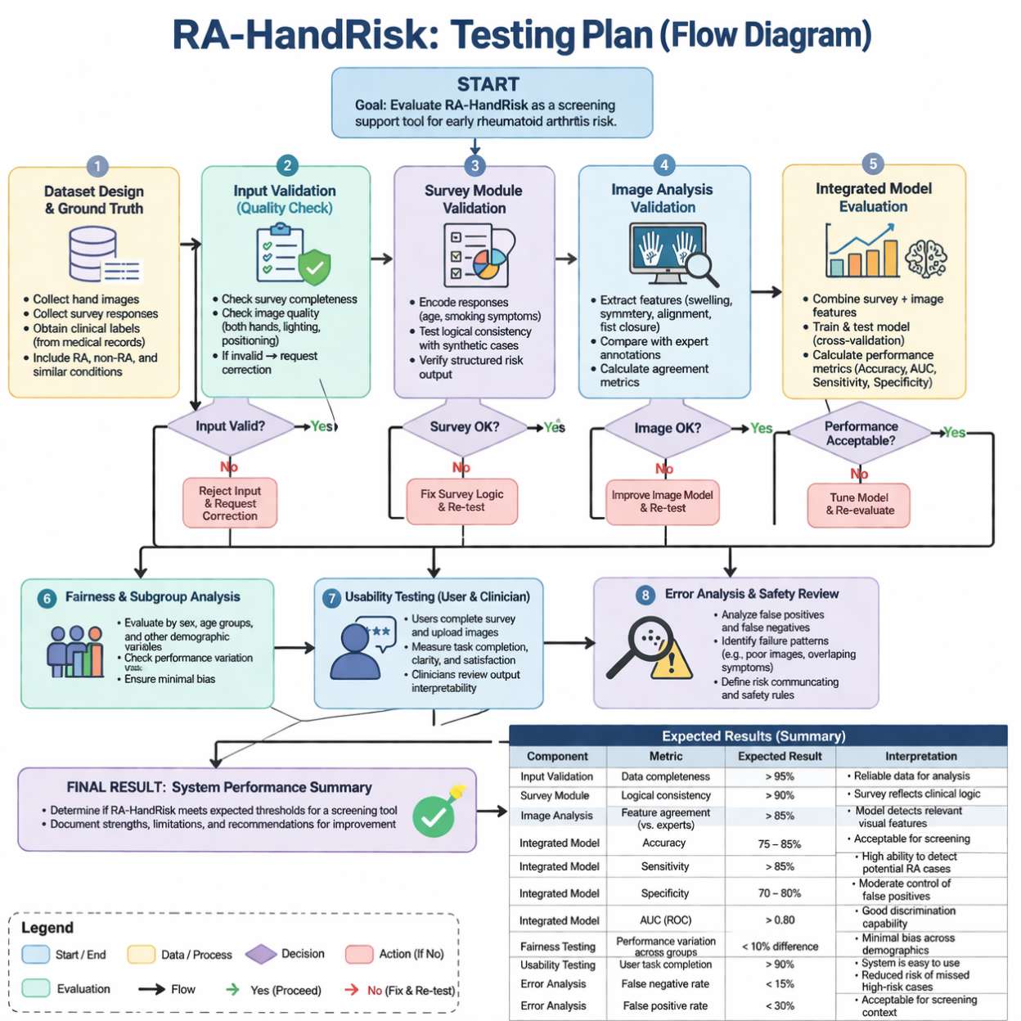
In conclusion, the RA-HandRisk testing plan should evaluate the system in layers: input quality, survey logic, image analysis, integrated prediction, subgroup fairness, usability, and safety. This approach is stronger than testing only final accuracy because it reflects how the system would actually behave in a real screening context. By combining clinical relevance, technical evaluation, and human-centered validation, the testing plan supports a more credible and scientifically grounded conceptual design.
References
Centers for Disease Control and Prevention. (2023). Rheumatoid arthritis (RA).
National Institute of Arthritis and Musculoskeletal and Skin Diseases. (2022). Rheumatoid arthritis symptoms, causes, and risk factors.
U.S. Food and Drug Administration. (2025). Good machine learning practice for medical device development: Guiding principles.
U.S. Food and Drug Administration. (2024). Transparency for machine learning-enabled medical devices: Guiding principles.
U.S. Food and Drug Administration. (2024). Clinical decision support software frequently asked questions.
World Health Organization. (2023). Rheumatoid arthritis.
Collins, G. S., et al. (2024). TRIPOD+AI statement: Updated guidance for reporting clinical prediction models that use regression or machine learning methods. BMJ, 385, e078378.

